Currency Converters

Google Currency Converter:

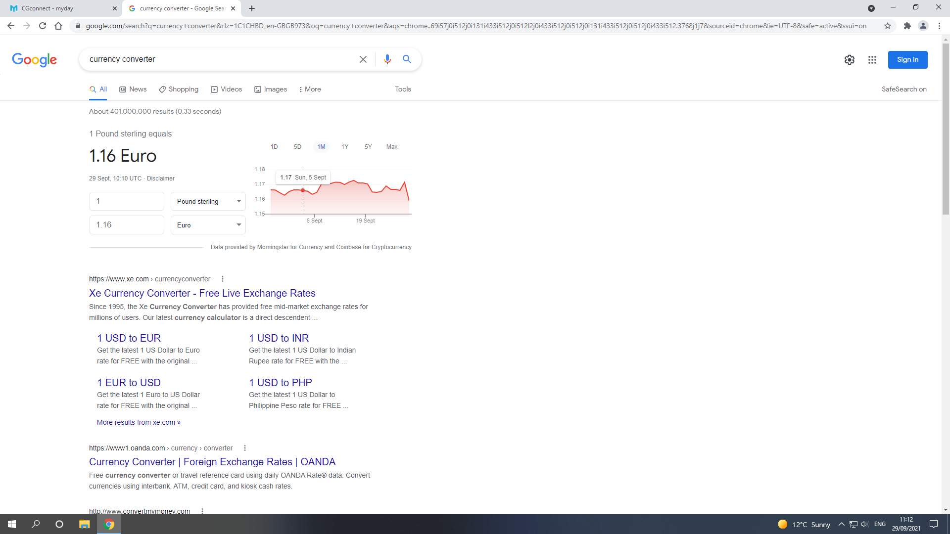

Data is entered through input boxes, and the currency can be selected through a choice box on the side. When you input the data, it is automatically outputted in the correct currency of the user’s choice. The data outputted is accurate to the date’s stocks. It also shows stock data on the right to show the user how it is doing.

Yahoo Currency Converter:

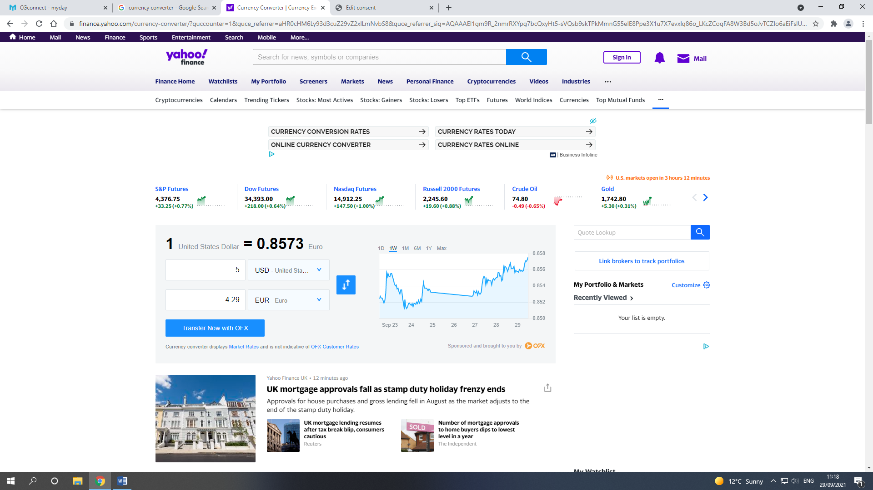

The Yahoo currency converter is similar to the Google one, it shows the current stock rate, and has similar input and output boxes to show the change as it is being inputted.

3 – 5 Currencies Exchange Rates

1 GBP = 1.16 Euro

1 GBP = 5.58 Sol

1 GBP = 1.35 USD

1 GBP = 68.75 Philippine Peso

1 GBP = 27.45 Mexican Peso

